Lab Exercise 17- Creating Secrets in Kubernetes

Vishal Pandey
500125280
B2 DevOps

Creating secrets in Kubernetes is an essential practice for managing sensitive information such as passwords, OAuth tokens, and SSH keys. Let's go through a lab exercise that demonstrates how to create different types of secrets in Kubernetes.

Step 1: Create a Generic Secret
Create a secret from literal values:
kubectl create secret generic my-secret --from-literal=username=admin --from-literal=password='P@ssw0rd'

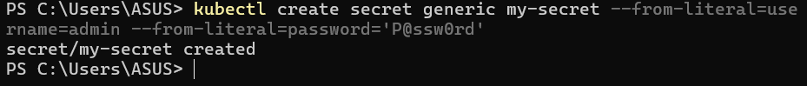

Verify the secret:
kubectl get secrets my-secret -o yaml

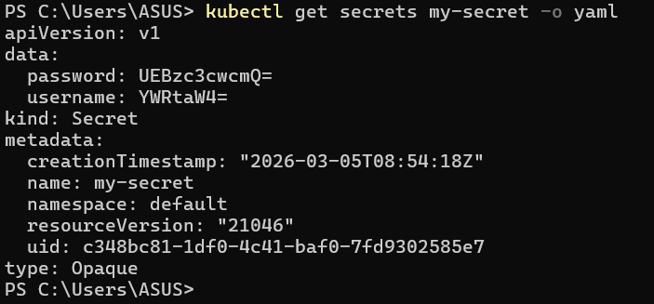

The output will be base64 encoded. To decode, you can use:

echo -n “P@ssw0rd” | base64

Step 2: Create a Secret from a File

Create a file with your sensitive data:

echo -n 'my-username' > ./username.txt

echo -n 'my-password' > ./password.txt

Create a secret from the file:

kubectl create secret generic my-file-secret --from-file=username=./username.txt --from-file=password=./password.txt

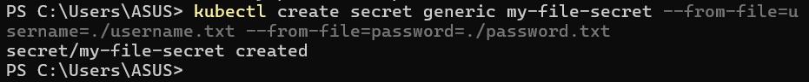

Verify the secret:

kubectl get secrets my-file-secret -o yaml

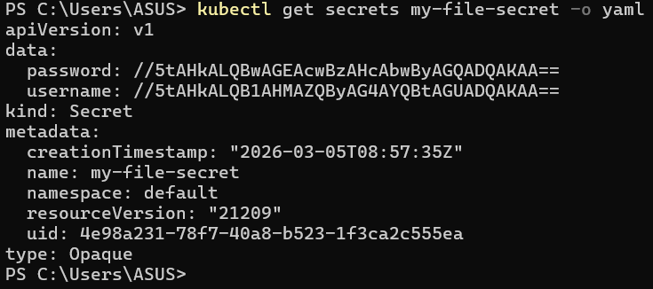

Step 3: Create a Docker Registry Secret

Create a Docker registry secret:

kubectl create secret docker-registry my-registry-secret --docker-username=<your-username> --docker-password=<your-password> --docker-email=<your-email> --docker-server=<your-docker-server>

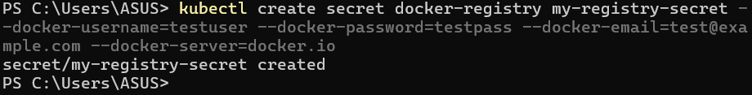

Verify the secret:

kubectl get secrets my-registry-secret -o yaml

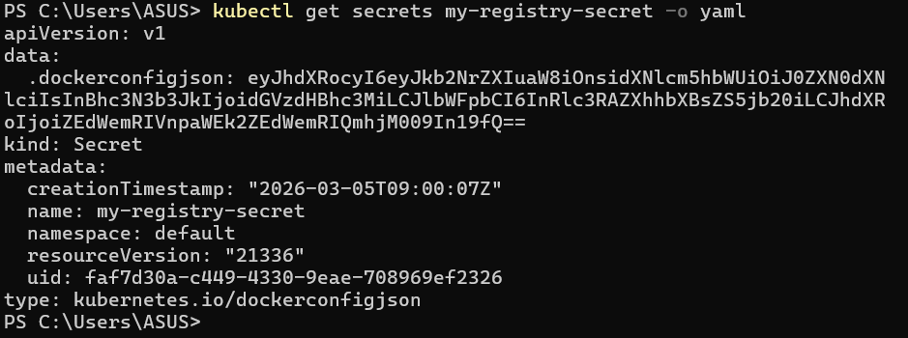

Step 4: Create a Secret Using a YAML Manifest

Create a YAML file for the secret:

Create a file named my-secret.yaml with the following content:

apiVersion: v1
kind: Secret
metadata:
name: my-manifest-secret
type: Opaque
data:
username: YWRtaW4= # base64 encoded value of 'admin'
password: UEBzc3cwcmQ= # base64 encoded value of 'P@ssw0rd'

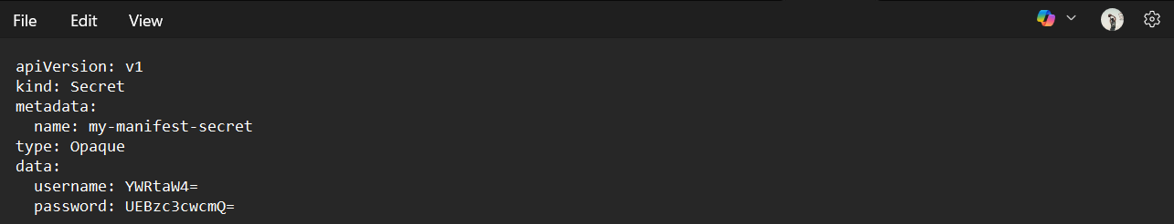

Apply the YAML file:

kubectl apply -f my-manifest-secret.yaml

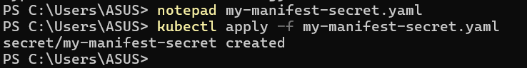

Verify the secret:

kubectl get secrets my-manifest-secret -o yaml

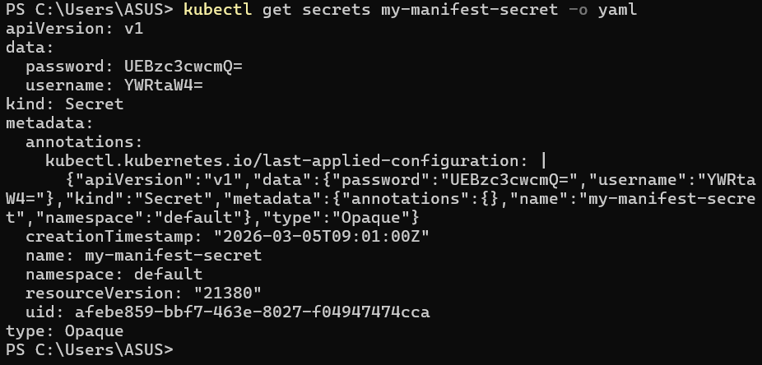

Step 5: Use Secrets in Pods

Create a pod that uses the secret:

Create a file named pod-with-secret.yaml with the following content:

apiVersion: v1
kind: Pod
metadata:
name: pod-with-secret
spec:
containers:
- name: mycontainer
image: nginx
env:
- name: USERNAME
valueFrom:
secretKeyRef:
name: my-secret
key: username
- name: PASSWORD
valueFrom:
secretKeyRef:
name: my-secret
key: password

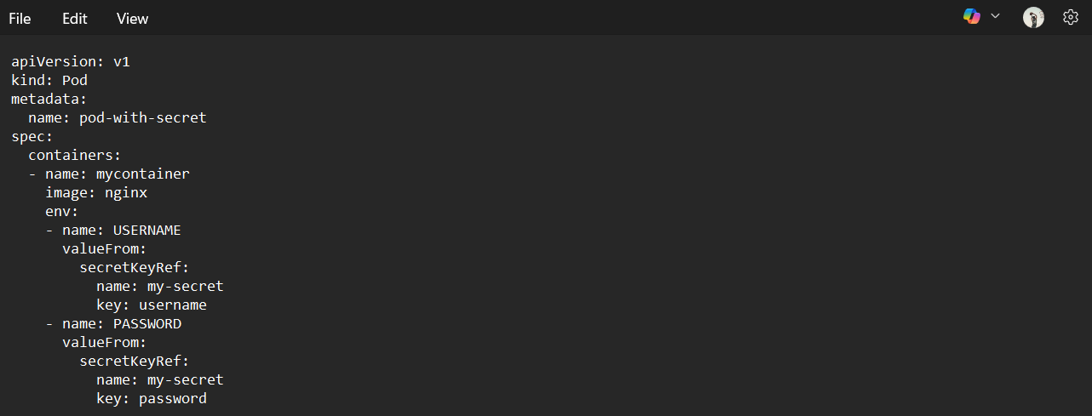

Apply the YAML file:

kubectl apply -f pod-with-secret.yaml

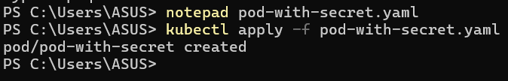

Verify the pod is running and the secret is being used:

kubectl exec pod-with-secret -- printenv | grep -E 'USERNAME|PASSWORD'

Step 7: Clean Up
Delete the secrets:
kubectl delete secret my-secret
kubectl delete secret my-file-secret
kubectl delete secret my-registry-secret
kubectl delete secret my-manifest-secret

Delete the pod:
kubectl delete pod pod-with-secret

